PRESS RELEASE

Mr. Hennayake Bandara, Vice President of the Institute of Certified Management Accountants of Sri Lanka has been appointed as President of South Asian Federation of Accountants (SAFA) and CA. Nihar N. Jambusaria, President of the Institute of Chartered Accountants of India has been appointed as Vice- President of SAFA for the year 2022 w. e. f. January 1, 2022. This is the first time that CMA Sri Lanka representative has been appointed as the President of SAFA since its admission as member of SAFA in 2010.

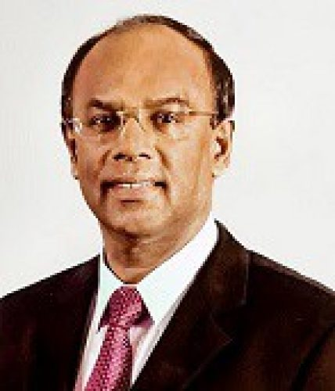
Mr. Hennayake Bandara
President, SAFA

Mr. Hennayake Bandara’s contribution to the field of Professional Education counts more than two decades in various capacities. He is a fellow (FCMA) and Founder Member of CMA Sri Lanka and joined the Council in 2012. He has been associated with SAFA since 2005. He also had the opportunity of working very closely with all Sri Lankan Past Presidents of SAFA. Mr. Bandara is a Past President of Association of Accounting Technicians of Sri Lanka (AATSL), Past President of Association of Professional Bankers - Sri Lanka (APBSL), Treasurer, Organization of Professional Associations of Sri Lanka and Council Member of Sri Lanka Institute of Advance Technological Education.

He has contributed immensely to the Banking Industry, serving as a General Manager/ CEO of National Savings Bank, the largest savings bank in the country. He has also been Director, NSB Fund Management Company Ltd; Chairman, NatWealth Securities Ltd; and Director, National Wealth Corporation Ltd. He has also served as a Board member of the World Savings Bank Institute (WSBI) representing the Asia & Pacific Region; Chilaw Finance PLC; Sabaragamuwa Development Bank; and the Institute of Bankers of Sri Lanka. He was a member of the expert group on the implementation of the “Stimulus Package for the Banking, Finance and Leasing Industry”, appointed to advise during the financial crisis by the Governor of the Central Bank of Sri Lanka, based on a Cabinet decision. He was the recipient of the CMA Award for “Excellence in Business Management” at the SAFA-CMA Management Accounting Summit held in 2012. Currently, he serves as an Advisory Council Member of APBSL, Independent Non-Executive Director Prime Finance PLC, and Council Member of the Institute of Chartered Professional Managers of Sri Lanka (CPMSL).

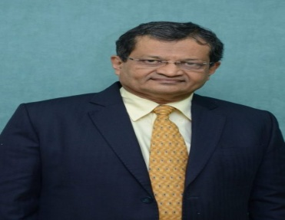
CA. Nihar N Jambusaria
Vice President, SAFA

CA. Nihar N Jambusaria is currently the President of the Institute of Chartered Accountants of India. A blend of erudition, experience, foresight, technical expertise and professional excellence worth emulating and a Fellow Chartered Accountant from Mumbai, CA. Jambusaria, qualified as a Chartered Accountant in 1984 and was in practice for nearly 27 years. CA. Jambusaria is the member of Professional Accountants in Business (PAIB) Advisory Group of International Federation of Accountants (IFAC) and representing ICAI on <IR> Council. He is also member of very important committees constituted by the Indian government and regulators relating to policy formation that include Government Accounting Standards Advisory Board (GASAB) and Audit Advisory Board- both constituted by the C&AG of India. He is also Board Member of Insurance Regulatory & Development Authority (IRDA), Insurance Advisory Committee and Apex Committee of IRDA, and Member of SEBI’s Primary Market Advisory Committee. He has also been nominated for the Services Sector Division Council (SSDC) of Bureau of Indian Standards and Chairman of Accounting and Finance Services Sectional Committee of BIS. He has also been nominated on the Review Committee for the B.Com (Hons) and B.Com New Syllabus for all the Universities in the Country by the University Grants Commission(UGC). He was a Member of the e – Commerce Committee formed by the Ministry of Finance and Peer Review Committee of the Central Board of Direct Taxes.

CA. Jambusaria has been a prolific speaker at national and international forum. As an academician and an orator par excellence, he has attended and contributed to numerous national and international seminars. He has addressed more than 900 seminars, conferences so far covering various subjects of professional interest like Direct Tax, Accounting Standards, International Tax and Professional Development and alike.

About SAFA
South Asian Federation of Accountants (SAFA), a Network Partner of IFAC comprises of eleven accountancy bodies in South-Asian Region namely India, Pakistan, Bangladesh, Sri Lanka, Nepal, Maldives and Afghanistan. Bhutan, where no accountancy body exists has been given an Observer status. SAFA has undertaken the leadership role in providing a new direction to the accountancy profession within the region and this Apex body has nearly 375,000 members affiliated with its member bodies. The Institute of Chartered Accountants of India is one of the founder members of SAFA and also hosts its Permanent Secretariat at New Delhi.

